**Assignment 2**

**Q1:-** Write a Program for deleting an element from the beginning and from any position?

**Answer:-**

#include<stdio.h>

void main()

{

int a[100],i,n,pos;

printf("Enter no of elements\n");

scanf("%d",&n);

printf("Enter the elements\n");

for (i=0;i<n;i++)

{

scanf("%d",&a[i]);

}

printf("Elements of array are\n");

for(i=0;i<n;i++)

{

printf("a[%d] = %d\n",i,a[i]);

}

printf("Enter the position from which the number has to be deleted\n");

scanf("%d",&pos);

for(i=pos;i<n-1;i++)

{

a[i]=a[i+1];

}

n=n-1;

printf("\nAfter Deletion, new array list we get is\n");

for(i=0;i<n;i++)

{

printf("a[%d] = %d\n",i,a[i]);

}

}

Output:-

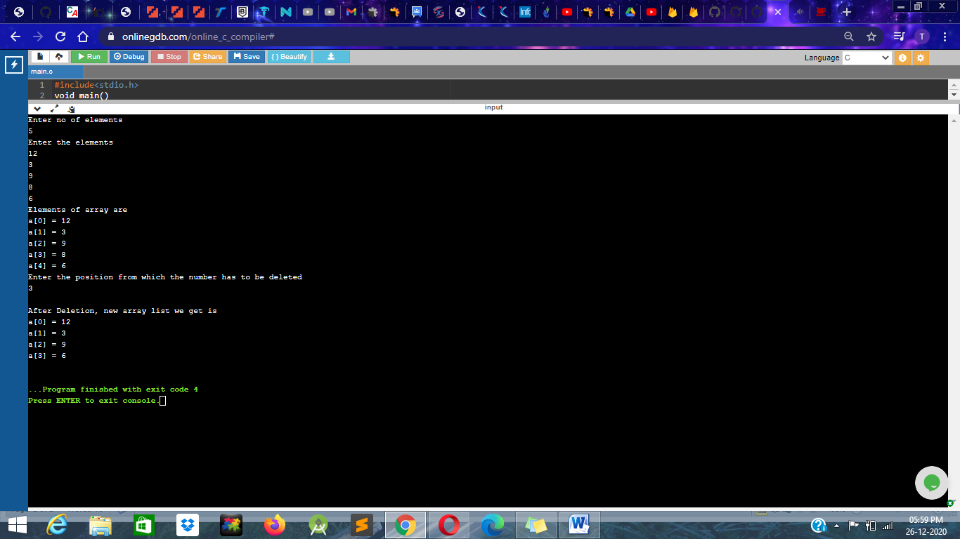

**Q2 :-** Write a Program for printing the array after rotating it K times towards left, where K would be taken as user input?

**Answer:-**

#include <stdio.h>

void leftRotatebyOne(int arr[], int n)

{

int temp = arr[0], i;

for (i = 0; i < n - 1; i++)

arr[i] = arr[i + 1];

arr[i] = temp;

}

void leftRotate(int arr[], int d, int n)

{

int i;

for (i = 0; i < d; i++)

leftRotatebyOne(arr, n);

}

void printArray(int arr[], int n)

{

int i;

for (i = 0; i < n; i++)

printf("%d ", arr[i]);

}

int main()

{

int arr[] = { 1, 2, 3, 4, 5, 6, 7 };

leftRotate(arr, 3, 7);

printArray(arr, 7);

return 0;

}

Output:--

